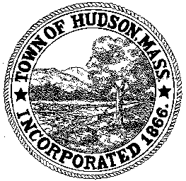

CONSERVATION COMMISSION
78 Main Street, Hudson, MA 01749
(978) 562-2020

Paul Byrne, Chairman W. Minot Wood, Vice Chairman David Esteves, Member

Terrence Joyce, Member Leif Longtine, Member Joseph Rodrigues, Member Al Tashian, Member

Meeting Agenda
October 4, 2012 7:00 P.M.

- Preliminaries
  - Open Meeting
  - Roll Call

2.0 New Business
2.1 Senior Center Landscape Project

2.2 Minutes: September 20, 2012

2.3 Request for Review and Comments
Cabot Ridge Apartments

2.4 Remote Participation during open meetings

3.0 Adjournment

